**Hands on 1**

**Spring Data JPA - Quick Example**

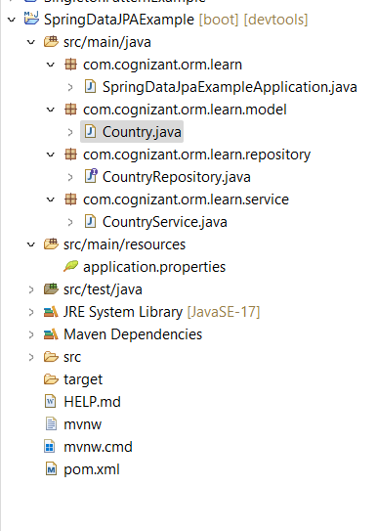 Project Structure:

application. properties

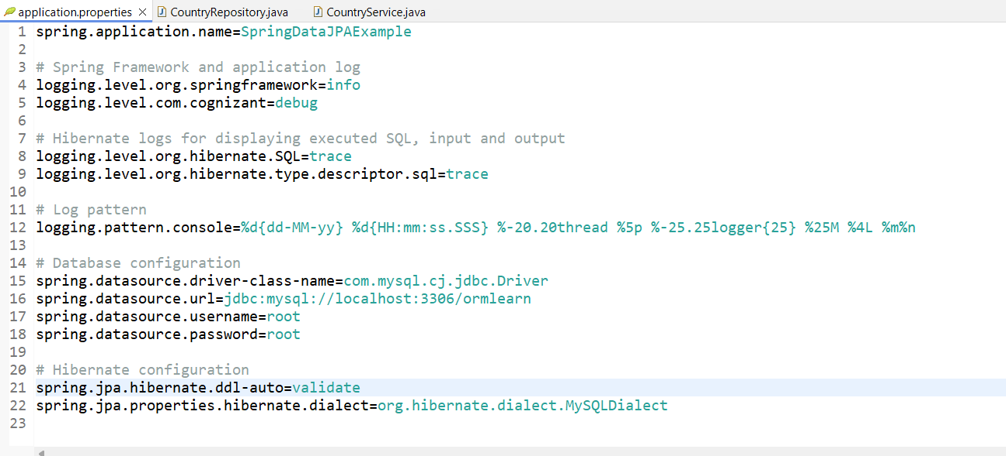

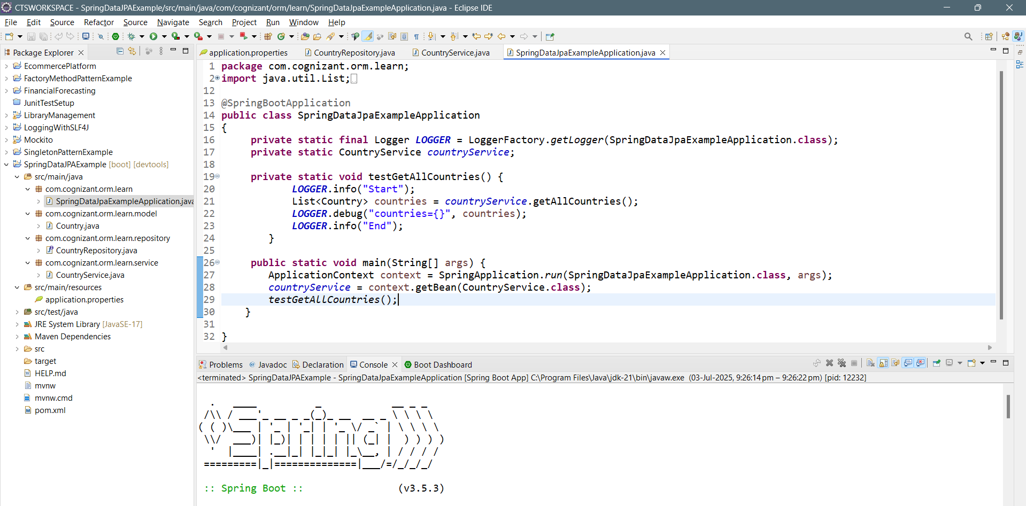 SpringDataJpaExampleApplication.java

CountryService.java

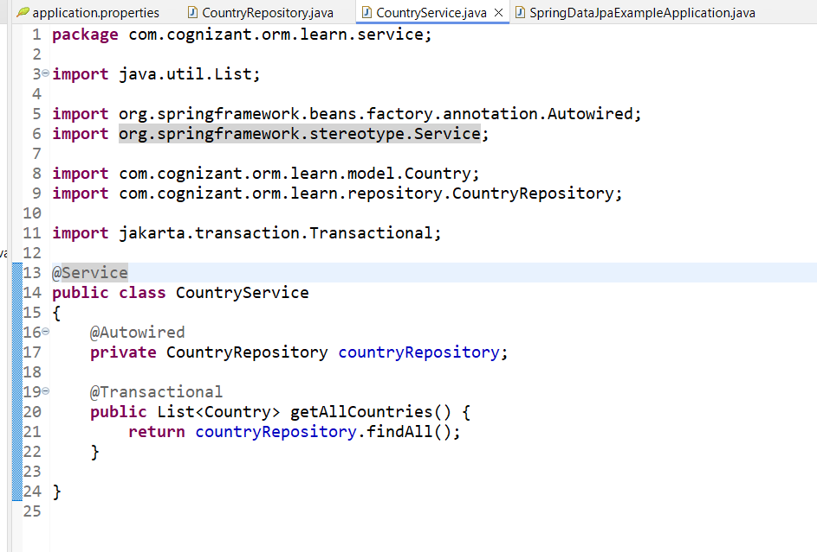

Created table and inserted some records:

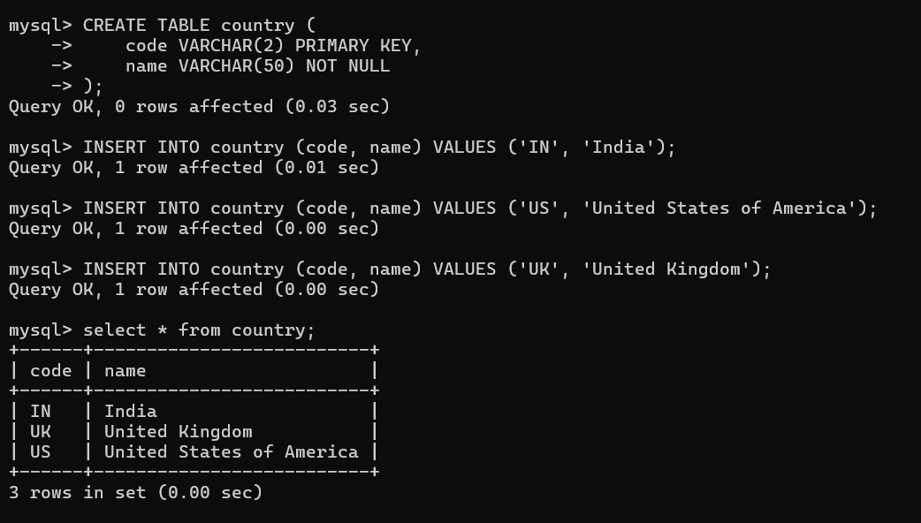

Console Output:

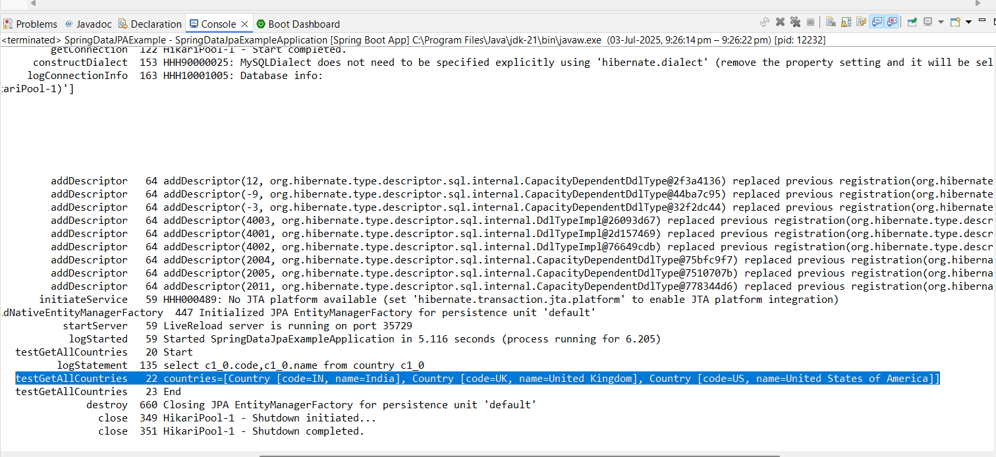The data from ormlearn database is retrieved.